ESCOLA ________________________________________DATA:_____/_____/_____
PROF:______________________________________________TURMA:___________NOME:_______________________________________________________________
Avaliação de Língua Estrangeira Moderna

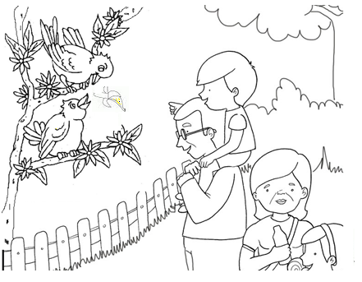
At the zoo
Jimmy: Look, dad! Those birds in that tree!
How funny they are!
Dad: They look like people!
Jimmy: Can I give these fruit to that one? The yellow one?
He is hungry. Look, he is sad!
He wants these fruit!
Dad: You can give the fruit, Jimmy.
( And Jimmy gives the fruit to the yellow bird.)
Jimmy: Now he is very happy. He is making grace. He is very funny!
5. ( ) Birds are big animals.
( ) Birds are funny animals.
( ) Birds are domestic animals.

6.Jimmy wants to give?
( ) popcorn to the yellow bird.
( ) fruit to the yellow bird.
( ) oranges to the yellow bird.

7.The birds make:
( ) grace
( ) toys
( )objects

8.The birds in the text is:
( ) big ( )yellow, funny, hungry
( ) unhappy
Choose the correct alternative.
( Escolha a alternativa correta.)
1.Where is Jimmy?
( ) Jimmy is at home.
( ) Jimmy is at school.
( ) Jimmy is at the zoo.

2.Where are the birds?
( ) The birds are on a car.
( ) The birds are in the park.
( ) The birds are in a tree.

3. ( ) Birds are big animals.
( ) Birds are funny animals.
( ) Birds are domestic animals.

4.What color is the bird in the text?
The bird in the text is __________.

